1. Some link is not work

Page error details - **Exception has occurred.**

_TypeError (type 'Null' is not a subtype of type 'String' in type cast) and search icon not working

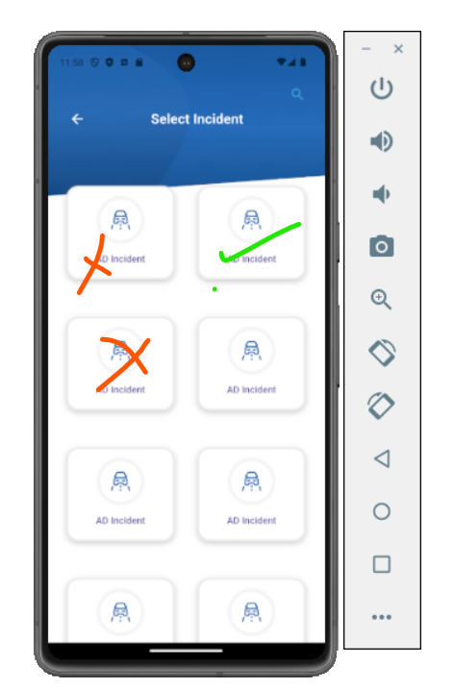

1. Upper portion just view typing message below section

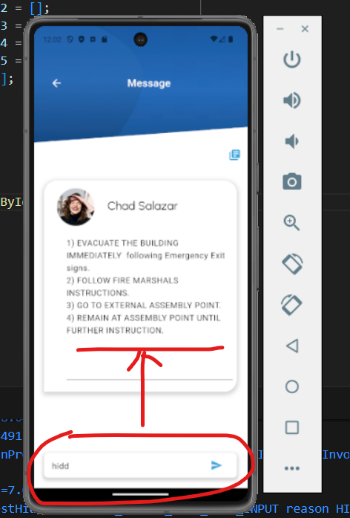

1. Back button hit and following error is coming this section. **Exception has occurred.**

_TypeError (type 'Null' is not a subtype of type 'String' in type cast)

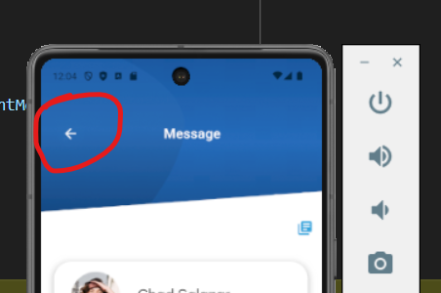

1. User to Notify

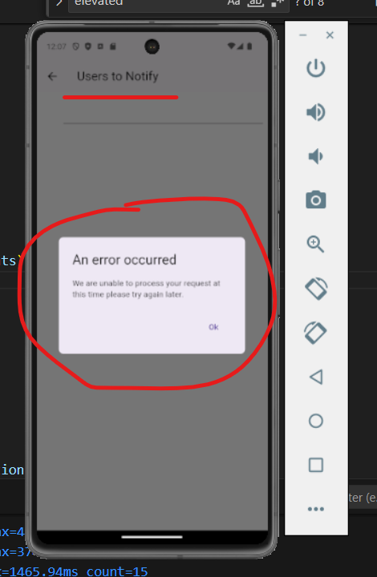

1. Incident Manager field same section is open

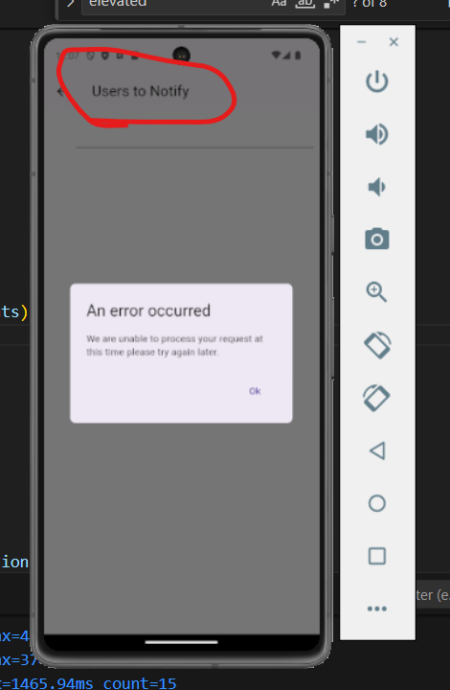

1. Social Post section is not open. **Exception has occurred.**

_TypeError (type 'Null' is not a subtype of type 'List<String>')

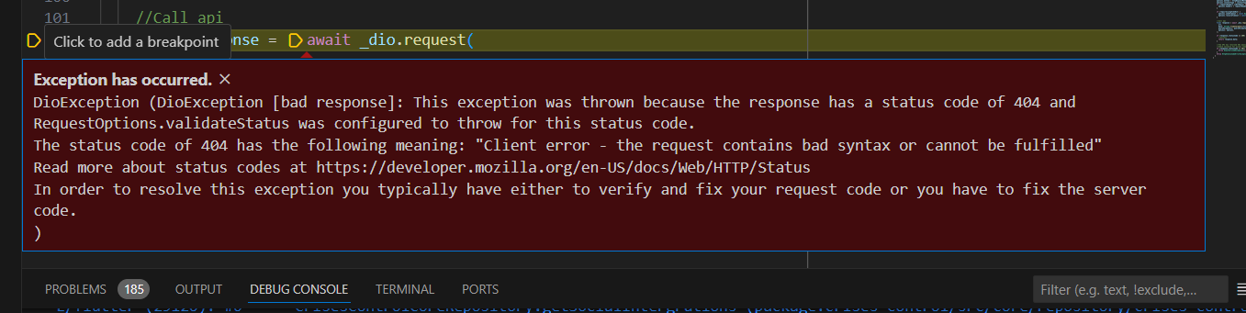

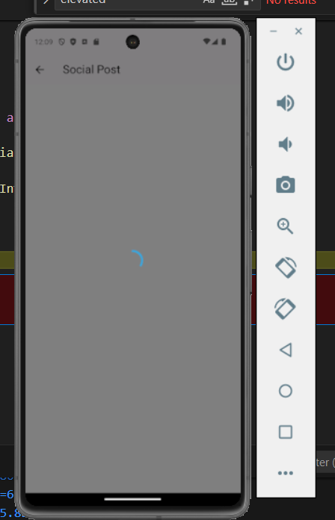

1. This screen shows following exception.

**Exception has occurred.**

_ClientSocketException (ClientException with SocketException: Failed host lookup: 'core.crises-control.local' (OS Error: No address associated with hostname, errno = 7), uri=https://core.crises-control.local/uploads/7/companylogos/884ccabb047162d92e6ada6a209c572f.jpg)

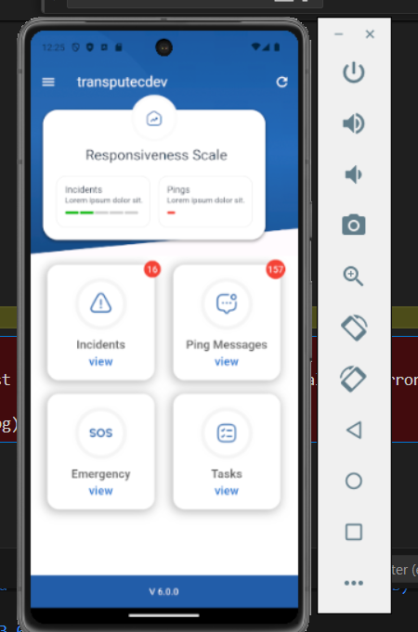

1. This error is coming from API

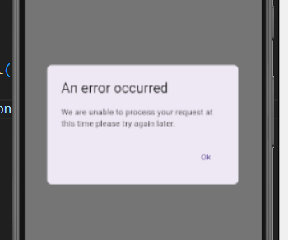

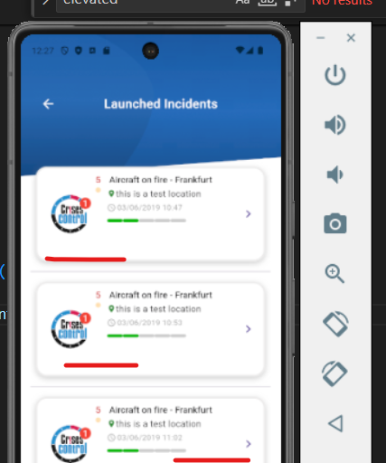

1. I don't know which page the Launched and Simulate button will redirect.

